FOCUS
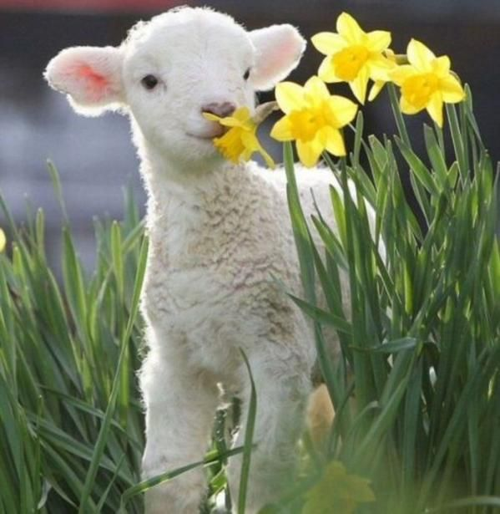
SPRING
2022
Dundee Blind and Partially Sighted Society
Thomas Herd House
10-12 Ward Road
Dundee DD1 1LX

Telephone: 01382 227101
E-mail: office@dbpss.org.uk
Website: www.dundeeblindsociety.org.uk

Alison’s Letter
Hello everyone,

I hope everyone managed to have a good Christmas break and it was a better experience than last year!

We unfortunately need to stop our activities early before the Christmas holidays and the dreaded lurgy cut short our delivery of our Christmas lunches but I am delighted to say that we had them in February for those that missed out. We even put up a Christmas tree, got out the decorations and had full blown Christmas lunches! It was actually really good fun for the Members and the team!

There is news further on in the Focus of the resumption of the social activities, and we are very hopeful that this is a positive step to getting us back to normality within the Society whilst still being able to support our Members that don’t attend activities.

I have good news on the vehicle front, as you may be aware we have only had the use of one vehicle after the other one was written off, but I have put in an order to replace the existing car with two new ones and we hope to take delivery in May. I hope to be able to give a further update in our Summer Focus.

I would like to thank everyone for all their generosity over the Festive period, we were completely overwhelmed to receive so many lovely Christmas cards, kind messages and gifts. Your continued support and kindness means so much to us all.
I am delighted to report that our new ventilation system is now in place and up and working, which means we can close the windows and some doors so we are not all freezing!

We are really looking forward to welcoming more of you back in the coming months.

Best wishes
Alison

Christmas Hamper Winners
We were also completely overwhelmed by the generosity of our Members and supporters who made a donation towards the Christmas Hampers raffle – in fact we received so much that we managed to have 7 raffle prizes including 3 substantial hampers!!

Thank you so much to everyone who made a donation to the raffles and supported us by purchasing raffle tickets.

Congratulations to our winners of the Christmas Hamper raffles who are listed below;

1st Prize Channyn Hart
2nd Prize Billy Connelly
3rd Prize Fiona Peters
4th Prize Kathleen Jackson
5th Prize Morag Harrison
6th Prize Kathleen Jackson
7th Prize Bill Ferguson

NEW MEMBERS THOUGHTS
As you know our Members are the main priority of Dundee Blind and Partially Sighted Society, with everything we do centred on the needs of every Member we have.

As well as having a wonderful group of existing Members we love nothing more than welcoming new Members into our little family.

Two of our newest Members include Mary Cumming and Libby Elliot who both kindly agreed to chat with me and have their new Members thoughts being featured in the Spring Focus.

From the very start of my chat with them it was clear that they really enjoyed attending the lunches at the Society, stating that they felt welcomed and part of the group from day one.

MARY’S THOUGHTS
Although I felt a little nervous when first attending the Society that quickly disappeared as I realised that both the other Members and the staff were very friendly and approachable. Nothing was a problem for them and it made me feel at ease. The best part of attending was the fact that everyone was in the same boat with regards to being visually impaired and it was nice to be able to talk to people who were going through the same as myself. It helped me talk about my sight loss and listen to how others coped with theirs. I’m now feeling much more confident about attending the lunches and am really looking forward to attending some of the activities when they restart in March. I would recommend the Blind Society to anyone with a visual impairment.

LIBBY’S THOUGHTS
I started coming along to the Society on the recommendation of my friend Mary Cumming, and I was not disappointed. From the first day I was welcomed and treated as though I had been coming along for years. The Society was accessible and staff were quick to give me the tour to show me where everything was. The lunches were excellent and great value for money. The menu was tailored to meet everyone’s requirements. The staff work really hard and since coming I feel everything has just fallen into place and I can be myself and chat with others about my sight loss without being judged. I’m really looking forward to trying out the armchair aerobics in the future as well as building on my confidence to attend more activities.

Well there you have it two lovely thoughts from two lovely Members. We love hearing the Members feedback both good and bad, so if anyone else has any thoughts or ideas they would like to put to us please feel free to call us on 01382 227101 or let us know in person if you attend the activities.

Board Members
We are on the lookout for new Board Members to join the Board of Directors and we would be interested in hearing from any Members who would like to be considered to join the Board. As a Member of the Board you will help us support the Governance and management of the charity.

Meetings are held every two months.

If you feel that you would like to involved, and could contribute to the Board, please speak to Alison if you would like further information.
Mission & Vision Statements
Alison and the Board of Directors have been reviewing the Society’s Mission and Vision Statements to reflect the changes made in the operation of the Society that has come about due to the pandemic.

Below are the new statements and we hope that you are in agreement with the way we see the Society going forward

DBPSS MISSION STATEMENT
DBPSS is working towards a world where all people who are blind or partially sighted enjoy the same rights, opportunities and responsibilities as everyone else

DBPSS VISION STATEMENT
Our Vision is to engage with all our Members to provide a holistic approach and making the Members the centre of our objectives. We will work with integrity and compassion in the aim of reducing feelings of social isolation and loneliness in those with a visual impairment. We will continually work to provide empathy, empowerment and a high quality service to ensure that every Member feels valued

Member Surveys
We would like to convey a huge Thank You to everyone that took to the time to complete and return the Members Surveys that were sent out to all of our Members in January, we are delighted to receive so many responses! It has given us a great insight into how our Members feel, and also given us some great feedback and ideas for the Society.
It is so heart-warming to know that we are appreciated by so many Members.

Here are some of the feedback comments and ideas we received;

“I have been very pleased with my phone contact with DBPSS over the last 2 years during Covid ups and downs. I feel much more connected to this group now”

“I would love to join a walking group”

“I am slightly nervous returning, but meeting people in small groups to see how everyone is would help me to start visiting again”

“Telephone calls and audio books have been so helpful”

One comment was regarding having an online facility to read the Focus and I would like to inform Members that the Focus can be emailed to them if preferred and it is also available on our website https://www.dundeeblindsociety.org.uk/news/

The survey results were anonymous so if you have any concerns or comments that you would like us to address, please give us a ring and we will be more than happy to try and address any comments/concerns/recommendations that you have.

If you would like to access any of our services or even wish for any type of support, phone calls, home visits then please call us on 227101

Resource Room
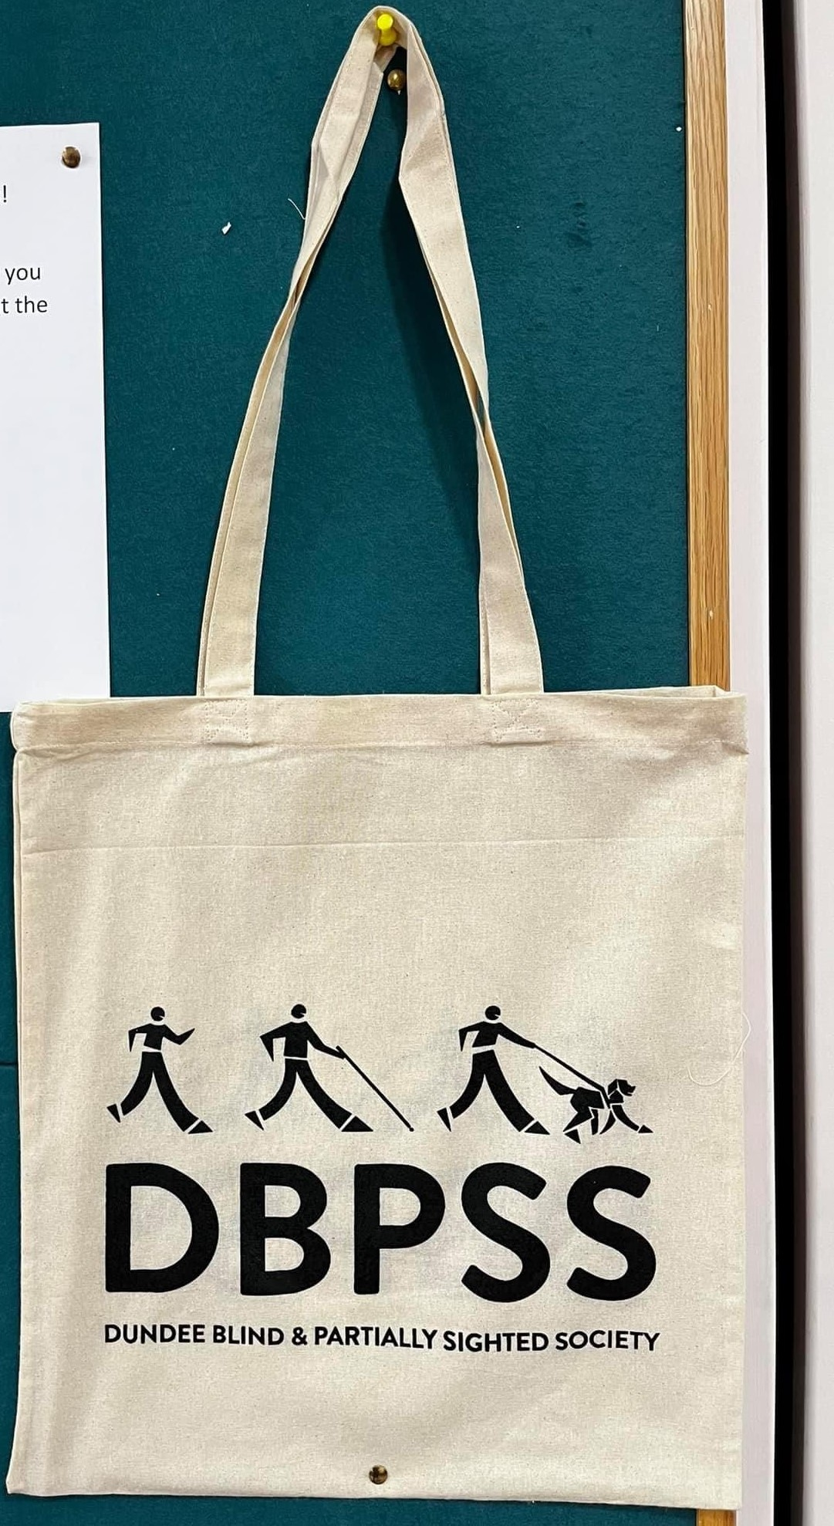
Our resource room is open and we are here to help if you have any questions or interest in any products that may be of assistance to you.

DBPSS Tote Bags
*** SALE ***
Our fabulous cotton tote bags are on sale with 25% off.

Now only £7.50
*while stock lasts
If you wish to order then please call us on 227101, we can pop one in the post to you!

Covid Safety Measures
It has become apparent reading through the Members Survey responses that some Members are reticent about returning to the Society or indeed attending activities for the first time due to being nervous of Covid –which is completely understandable.

To help alleviate anxieties and hopefully instil some confidence to enable Members to join us in the Society we have put together the following measures to reduce the risk of infection to our Members, visitors and staff;

• Everyone that enters the building will be requested
to have their temperature taken
• There is a hand sanitiser station at the entrance
and sanitiser is available in activity rooms. We will
ask you to sanitise your hands on entry to the
building and after attending the toilet
• Face masks should be worn when not seated
(if not exempt)
• All common areas will be cleaned and sanitised at
the end of each day
• Ventilation systems have been installed and will be
in full use at all times
• Co2 monitors are situated in the activity rooms and
a response plan will be adopted if the alarm is
sound
• We have a Covid Response Risk Assessment that
can be viewed on request

If you would like to visit the Society and have a cup of tea and chat with us before deciding whether to attend activities please just give us a ring on 227101 and that can be arranged. We do not want any of our Members missing out or being isolated due to a lack of confidence of attending.

Scotland’s Census 2022
Between 28th February and 2nd March, you will be receiving a letter asking you to complete the Scotland Census for 2022. This happens every 10 years, and the data is collected and used to help gather vital information about our health care, population and other areas too.

The Census must be complete and returned by Scotland Census day on Sunday 20 March.
For the Census 2022 they have issued a letter to every household, asking them to complete the information with a code via the internet.

Paper copies will not be issued with the letter.
If you require a paper copy you can request this by calling 0800 0308308 or online at www.census.gov.scot/paper.
We are aware that not all of our Members are able to access the internet, and may also not have anyone that can access the internet for them.

If any Member requires any assistance with completing the Census or requesting a paper copy to complete, then please call us on 227101 and we are happy to assist.

Activities
After what feels like such a long wait, we are delighted to announce that we are planning to start having activities back at the Society.
We are hopeful that all being well, our new Activity timetable can start on Monday 7th March with the lunch club starting Wednesday 16th March.

NEW!! Boccia kicks off our week on a Monday! Come and try your hand in a game of precision, skill and tactics – with some fun, a cuppie and company thrown in! An optional light two course lunch is available.
The Bingo Club allows Members to play this popular game in a friendly and supportive setting. The amount of noise and laughter that emanates from the clubroom during the session would indicate that those who come to this find it great fun.
The Games Morning on a Tuesday are a great opportunity to have some fun and get competitive! We have a range of indoor games including bowling, curling, shuffleboard, velcro darts and bean bag toss. Judging by the hilarity that comes from the games area we believe this is a very popular activity in the Society!
NEW!! Fun Drum on a Wednesday morning is a fabulous fun way of getting some exercise and getting in to the rhythm! Fund Drum involves a yoga ball, drumsticks and some rocking music!
The Lunch Club offers a scrumptious 2 course meal consisting of either a soup and main course or a main and pudding. The food is lovingly prepared on the premises and made from locally sources fresh ingredients. Favourites are mince and tatties to roast joints to tasty pasta dishes as well as yummy chocolate puddings and warming hot soups. Definitely a group for the foodies amongst us!
Armchair Aerobics Join us for Armchair Aerobics on a Friday, a favourite with the Members. They put their all into the exercises and they have even designed tee shirts to work out in, they are known as The Ward Road Warriors! 2 course light lunch provided
Tea and Chat does exactly what it says on the tin. This popular session allow people to come together for a bit of a blether and the occasional singsong if they feel like it, we are hoping to get back to having live music every 3 weeks in the near future.
COMING SOON
Choir – If Games aren’t your thing, you can sing your heart out at the Choir! You don’t need to be able to hold a tune just come along and sing!
To help keep us all safe, we have chosen to keep numbers for activities limited to around 15 in the first instance and activities will need to be booked before attending. They can be booked by speaking to us in the Society or by calling us on 227101.

We look forward to seeing many of you returning to take part.

Unfortunately we are currently unable to offer transport to Members, we hope this may be reviewed in the future.

Activities Price Review
The Society has always aimed to keep our costs for activities and lunches as low as possible but due to rising costs, we have unfortunately had to introduce a slight increase the activity and lunch costs.

- Daily activities will rise to £2 and £5 if including the light lunch provided

- Lunch Club will rise to £7.00 for a two course home-cooked lunch with refreshments and tea/coffee.

- Bingo books will now cost -
1 book - £4.00
2 books - £6.50
3 books - £8.00

Refreshments at the Bingo can be purchased
for £1.50

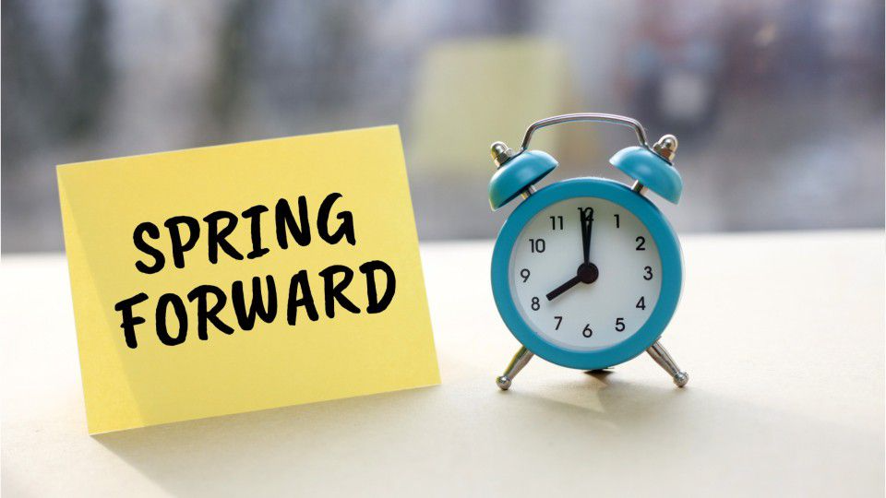

Clocks “spring” forward
A little reminder that clocks all move forward one hour on Sunday 27th March. If anyone needs any assistance with clock changes then please just us know.

Low Vision Support & Product Clinic
Would you like support with your Sight or Technology?
Optelec will be attending the Society on Wednesday 27th April to run a clinic and they will be offering one-to-one 45 minute support sessions with their experienced Low Vision Specialist.
You will be able to receive advice and hands-on experience with Low Vision Aids.
By Appointment only between 10am – 4pm, please call 0800 145 6115 or the Society to book a slot



You are warmly invited to join the Low Vision Service Conversation - shape the new service
There is work underway to develop a National Low Vision Service for Scotland. Low Vision Services, sometimes known as Low Vision Aid Services, help people use their vision as best they can. For example, assessment and supply aids or lighting to help with every-day tasks.
You can shape the new service by sharing:
- Your views, opinions and experiences of the Low Vision Services in Scotland you have accessed before or during the pandemic
- Your thoughts on positive and negative impacts of the pandemic on provision, delivery and access to Low Vision Services
- Your expectations of a high quality National Low Vision Service
Take Part in Shaping the Service:
You can take part in 5 different ways:
- Complete an online Survey https://www.smartsurvey.co.uk/s/COKXUW/
- Complete an electronic Survey Questionnaire
- Complete a large print postal Survey Questionnaire
- Participate in a small online Focus Group
- Participate in an individual telephone discussion
The information you provide will inform the development of the new National Low Vision Service for Scotland.
If you would like to request an accessible survey, arrange a telephone discussion or have any queries, please contact Dr Hazel McFarlane, Senior Sensory Hub Officer, Health and Social Care Alliance Scotland.
Email: sensory@alliance-scotland.org.uk
Mobile: 07595 453 318

Kiltwalk 2022
I am pleased to report that the team, some of our amazing Members and supporters have signed up to undertake the Kiltwalk Wee Wander on Sunday 21st August.
We will be donning our kilts and praying for dry weather but it will be a great day out and a great opportunity to raise funds for the Society!

If you would like to sponsor the team please get in touch or you can make a donation online at https://www.dundeeblindsociety.org.uk/news/kiltwalk-2022/

Every penny that you donate to the charity will be topped up by a HUGE 50%* thanks to the generosity of Sir Tom Hunter and The Hunter Foundation. That means if you donate £10, we will receive £15!


Puzzle Time
1 |  | 2 |  |  | 3 | 4 |  | 5 |  | 6 |  | 7
 |  |  |  | 8
9 |  |  |  |  |  | 10
11 |  | 12 |  | 13
14 |  |  |  | 15 |  |  | 16
 |  |  |  |  |  | 17
18 |  |  |  |  |  |  |  | 19 |  | 20 |  | 21
22 |  |  |  |  |  |  |  | 23 |  | 24
25 |  |  |  |  |  |  |  |  | 26

Clues Across
1 – gloomy looking (weather) (4)
3 – French statesman (2,6)
9 – grate, grind (5)
10 – army unit (7)
11 – twitch of nerves (3)
13 – for each person (3,6)
14 – Judith …… Novelist (6)
16 – work out in the mind (6)
18 – root out (9)
20 – coniferous tree (3)
22 – table (7)
23 – even (5)
25 – introduces (8)
26 – shove (4)

Clues down Crossword
1 – authorised (5)
2 – employ (3)
4 – go aboard ship (6)
5 – disturb (7)
6 – encumbrance (9)
7 – raise (7)
8 – omit (4)
12 – wild sour fruit (4,5)
14 – part of the leg (7)
15 – homage (7)
17 – stipulation (6)
19 – jazz singer …. Fitzgerald (4)
21 – fail to pay debt (5)
24 – computer screen (1,1,1)

Word Search – HAVE A NAP

BUNK NIGHTCAP SLEEP
COUCH RECLINE RELAX SLUMBER DOZE TIRED
SHUTEYE WEARY SIESTA YAWN GO TO BED
FORTY WINKS



Word Search – HAVE A NAP

E | N | I | L | C | E | R | E | N | C | N | H
G | D | K | E | U | E | Y | A | W | N | I | M
E | O | E | B | S | N | Z | K | Z | N | G | F
R | N | T | Y | C | R | N | O | B | P | H | O
I | E | O | O | H | U | L | X | D | W | T | R
H | I | B | C | B | T | Y | A | C | L | C | T
S | O | U | M | A | E | A | L | B | I | A | Y
Y | O | L | T | U | I | D | E | S | S | P | W
C | R | X | B | Q | L | O | R | H | W | P | I
U | K | A | E | T | N | S | U | U | E | F | N
E | J | D | E | R | I | T | O | E | K | U | K
D | P | R | T | W | E | G | L | Y | H | O | S
S | W | R | E | Y | U | S | E | C | T | E | H
A | T | S | E | I | S | S | Z | I | G | S | L

SuDoku – Each Horizontal /Vertical line must contain one and only one of each digit 1-9

4 |  | 6 |  | 5
 |  |  | 4 |  | 3 |  |  | 6
 |  | 8 |  | 6
8 |  |  | 2 |  |  | 1 |  | 4
 | 1 |  |  |  |  |  | 5
3 |  | 9 |  |  | 7 |  |  | 8
 |  |  |  | 1 |  | 3
7 |  |  | 9 |  | 2
 |  |  |  | 7 |  | 2 |  | 9

 |  | 7 | 6 |  |  |  | 2
 |  | 8 |  | 7
1 | 4 |  | 3 |  |  |  | 5
 |  |  |  |  | 6 | 3
 | 9 | 2 |  |  |  | 6 | 7
 |  | 5 | 9
 | 6 |  |  |  | 3 |  | 1 | 2
 |  |  |  | 5 |  | 9
 | 2 |  |  |  | 1 | 8

Puzzle Time Solutions
L | O | U | R |  | D | E | G | A | U | L | L | E
I |  |  |  | S |  | M |  | G |  | I |  | L
C | R | E | A | K |  | B | R | I | G | A | D | E
I |  |  |  | I |  | A |  | T |  | B |  | V
T | I | C |  | P | E | R | C | A | P | I | T | A
 |  | R |  |  |  | K |  | T |  | L |  | T
K | R | A | N | T | Z |  | D | E | V | I | S | E
N |  | B |  | R |  | C |  |  |  | T
E | R | A | D | I | C | A | T | E |  | Y | E | W
E |  | P |  | B |  | V |  | L |  |  |  | E
C | A | P | S | U | L | E |  | L | E | V | E | L
A |  | L |  | T |  | A |  | A |  | D |  | C
P | R | E | S | E | N | T | S |  | P | U | S | H

So-Duko

4 | 3 | 6 | 8 | 5 | 1 | 9 | 7 | 2
9 | 7 | 5 | 4 | 2 | 3 | 8 | 1 | 6
1 | 2 | 8 | 7 | 6 | 9 | 4 | 3 | 5
8 | 6 | 7 | 2 | 3 | 5 | 1 | 9 | 4
2 | 1 | 4 | 6 | 9 | 8 | 7 | 5 | 3
3 | 5 | 9 | 1 | 4 | 7 | 6 | 2 | 8
6 | 9 | 2 | 5 | 1 | 4 | 3 | 8 | 7
7 | 4 | 3 | 9 | 8 | 2 | 5 | 6 | 1
5 | 8 | 1 | 3 | 7 | 6 | 2 | 4 | 9

9 | 3 | 7 | 6 | 4 | 5 | 1 | 2 | 8
2 | 5 | 8 | 1 | 7 | 9 | 4 | 6 | 3
1 | 4 | 6 | 3 | 8 | 2 | 7 | 5 | 9
4 | 8 | 1 | 7 | 2 | 6 | 3 | 9 | 5
3 | 9 | 2 | 5 | 1 | 8 | 6 | 7 | 4
6 | 7 | 5 | 9 | 3 | 4 | 2 | 8 | 1
7 | 6 | 4 | 8 | 9 | 3 | 5 | 1 | 2
8 | 1 | 3 | 2 | 5 | 7 | 9 | 4 | 6
5 | 2 | 9 | 4 | 6 | 1 | 8 | 3 | 7

Activity Timetable 2022

Monday
Boccia | Activity only £2.00 | 1100 |  | 1215
Light Lunch | Activity with lunch included £5 | 1215 |  | 1450
Tuesday
Games Morning | Activity only £2.00 | 1100 |  | 1215
Light Lunch | Activity with lunch included £5.00 | 1215 |  | 1315
Bingo | 1 Book £4.00 | 1315 |  | 1450
 | 2 Books £6.50
 | 3 Books £8.00
 | *Tea/Coffee can be purchased for £1.50
Wednesday
Fun Drum | Activity only £2.00 | 1100 |  | 1200
Lunch Club | Lunch Club £7.00 | 1215 |  | 1400
Thursday
Line Dancing | Activity only £2.00 | 1100 |  | 1215
 | Activity with lunch included £5.00
Light Lunch |  | 1215 |  | 1315
Bingo | 1 Book £4.00 | 1315 |  | 1450
 | 2 Books £6.50
 | 3 Books £8.00
 | *Tea/Coffee can be purchased for £1.50
Friday
Armchair Aerobics | Activity only £2.00 | 1100 |  | 1215
Light Lunch | Activity with lunch included £5.00 | 1215 |  | 1315
Tea & Chat | Activity only £3.00 | 1315 |  | 1450

