FOCUS

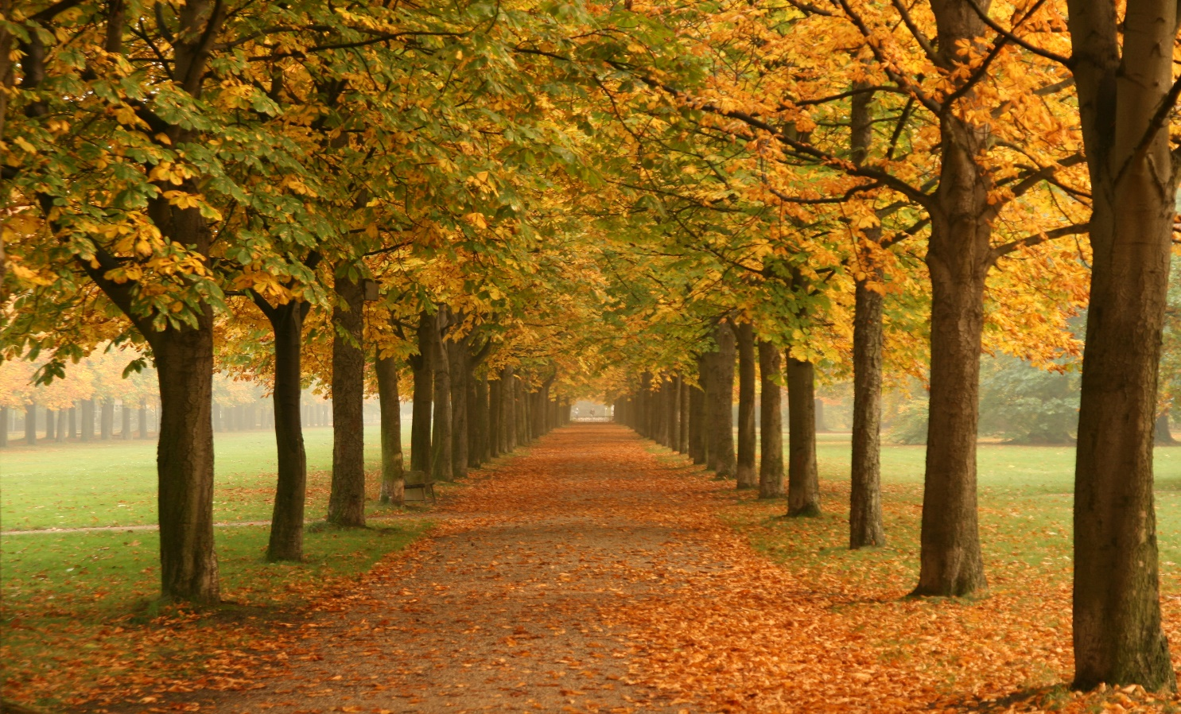

AUTUMN

2024

**Dundee Blind and Partially Sighted Society**

**Thomas Herd House**

**10-12 Ward Road**

**Dundee DD1 1LX**

**Telephone: 01382 227101**

**E-mail:** [**office@dbpss.org.uk**](mailto:office@dbpss.org.uk)

**Website:** [**www.dundeeblindsociety.org.uk**](http://www.dundeeblindsociety.org.uk)

**Laura’s Letter**

Hello everyone,

I hope that everyone has had a lovely summer despite the typical British weather!

I just wanted to take this opportunity to introduce myself for those who I have not met yet. I was recently appointed as Service Manager on the 1st of July 2024.

I have worked in previous roles within the charity sector and local government. I am committed to advocating on behalf of blind people and those visual impairments and raising public awareness. I am delighted to take up this role of Service Manager at Dundee Blind and Partially sighted Society where I can continue to support our members as well as linking in with other organisations in continuing the growth towards the future and on that note it was agreed by the Board Members at our last meeting that for any new members who join the society we will take a one of joining fee of £10 going forward rather than an Annual Membership Fee however if anyone wishes to make a donation to the society it would be greatly appreciated.

I look forward to meeting you all.

Best Wishes

*Laura*

**WING WALK – 31ST MAY 2024**

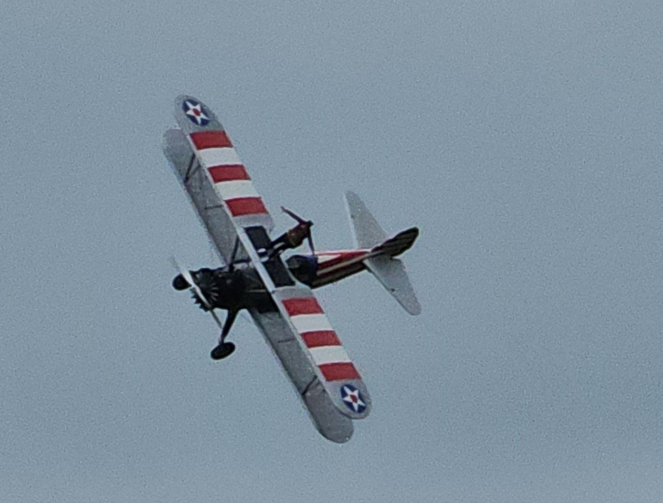

Just as you were receiving your summer’s edition of the Focus I was heading down to Somerset to take part in my Wing Walk. I was extremely excited as I left Edinburgh to do the challenge, but that excitement didn’t last long!

On the day, I woke up and the sun was shining and there was a gentle breeze, all conducive for a good day for it to go ahead, we were “all systems go”.

My first glimpse of what I had let myself in for was when we pulled into the airfield, and I saw an aircraft already in the air with their precious cargo of a wing walker attached to the top of the wing. It was like watching a combination of an elegant swift followed by a ferocious seagull. The swift gliding effortlessly through the sky with the occasional dive bombing of the seagull as if it were after and ice cream of a holiday maker at the beach. The combination of the twists and turn and ups and downs was starting to make my own stomach do somersaults and I was still firmly on the ground!!!!

Whilst I was waiting for my “briefing” I thought I would get myself a coffee, maybe not such a good idea. I was already shaking but the effects of the caffeine took it to another level. My friend Steve actually asked me if I wanted to go home as he would orchestrate my escape. Tempting though it was I was there for a purpose and I decided to go through with it.

After signing all the disclaimers and watching a video that ended with the phrases that “in the event that they had to do an emergency landing it could result in serious injury or death”, I was led out to my ‘chariot’.

Once I was at the side of the plane the pilot, Joe, asked me what sort of ride I would like? I told him that I wasn’t entirely sure as I did suffer a little bit from travel sickness. He reassured me that he would take it easy to start off and I was shown the signal that I should use if I wanted to go back down. He told me that if I occasionally waved my hands then he would know I was okay.

It was a little bit of a tricky climb up onto the top of the wing but if the lady before me, who was 83 could do it, so could I. Once on top I was strapped firmly into place and told quite sincerely not to touch the safety release button. Why is it that as soon as someone tells you not to touch something you immediately want to do it?

The airplane was a beautiful bi-plane that had been build in 1942 and had, I was reliably informed, been well maintained and I must admit that when the engine started and the propellor started to go round it made that lovely sound that you’ve probably heard in the past in old war movies.

We taxied down to the end of the runway and turned. The take-off/landing strip stretched off into the distance and I could just about see my daughter, Charley and friend Steve, standing at the barrier poised with their cameras. It was at this point Joe the pilot informed me that the more I waved my hands the more “daring” the flight would be. I only found out he had said this when I watched back the recording of the flight as I had absolutely no way of hearing him at all because of the noise!

The sound of the engine changed and we started to move off down the runway. I stretched my arms out so I could experience to the fullest the speed and take off. As I passed the viewing area I waved to Charley and Steve and we were in the air. It was exhilarating!

Joe kept to his word and the first few minutes where nice and gentle, just a sedate glide around the airfield. According to my instructions I kept waving my hands to show Joe that I was okay and enjoying it. However, Joe took this as an indication that I was REALLY enjoying it and wanted to up the thrill level. This is when the dive bombing like a seagull started and the swooping like a swift. We went left and right, up and down. One second I was experiencing g-force the next zero gravity. This went on for, what felt like, an extraordinary amount of time. We would plunge down towards the runway and I would think we would be about to land only to soar upwards again. Each time we did this I would wave frantically at the spectators, an indication to Joe that I was really enjoying myself!

After about 13 minutes of this I was starting to feel a little queasy, so I dropped my arms and held onto the frame. Joe took the hint and we made one final turn and headed back to the runway. As we approached and the lower we got I could feel the temperature rise and I got the impression that we were speeding up but I think this was because we were passing buildings and trees and I could see how fast we were actually going. When we were up in the air there had been no reference points to appreciate how quick we had been flying, between 70-120 mph.

Once we had taxied back and were at a standstill it was time to get down which was made a little trickier by the fact my legs were wobbly, however, it turns out getting down was simpler than getting up, thank goodness. I shook Joe’s hand and thanked him (I think) for the flight!

With feet firmly on terrafirma and after consuming a hot cup of tea my nerves were calm enough for me to contemplate what I had done. Would I do it again? Probably not. Did I enjoy it? The first 8 minutes, yes, then it went on just a little bit too long. Was it worth it? Definitely, I managed to raise a staggering £2,300 for the Society.

I would just like to take this opportunity to thank everyone who donated, took sponsorship forms and hounded their friends and relatives for money. It is an amazing amount of money to raise and of course every single penny will be put towards helping all our members.

I definitely think I have earnt my wings!!!!

Thank you, Helen

**NAME CHANGE**

The Name change is still currently being reviewed and the 3 options that we would like your preference on are :

Sight Loss Centre

Sight Support Service

Sight Support Organisation.

If you would like to let us know which one you would prefer please get in touch.

Our next AGM will be coming up on the 24th of October 2024 at 3:30PM – Let us know if you would like to come along!

**DBPSS & NESS**

**Drop-in sessions**

You will recall in the Summer Focus we mentioned that the team from NESS will be holding a series of drop-in clinics for our Members. So far, they have been in to give help and advice on accessible technology and benefits/concessions. The next session will be on:

* Tuesday 17th September – Exploring Independent Living Skills
* Wednesday 2nd October 2024 – Accessible Technology (Including Mobile Phone Support)
* Thursday 17th October 2024 - Benefits and Concessions

The drop-in sessions will be held at 10.30am-12.30pm.

These sessions give our Members the opportunity to get to know the team at NESS, so please do come down to the Society if you are looking for any advice or assistance.

**Open/Taster Day**

On Wednesday 21st August we held our open day designed to showcase the Society and the activities we offer. If you had visited that day you would’ve been able to sample some of the following

* Try out the activities such as drum fit, seated dancing, line dancing and indoor games
* Sample our tasty treats!
* Hand/Head massages
* Meet fellow Members

Unfortunately, due to the inclement weather that day it was poorly attended so we will look to rescheduling it again for Wednesday 30th April 2025.

We would like to encourage anyone who is interested in coming in to see what we do and is maybe feeling a little shy please come down and visit us, you are of course welcome to bring a family member or friend.

**MAGIC MOMENTS**

We have continued to have our monthly visits from some of our smallest friends and their mums. The Bairns Group arrange for local mums to bring their young babies down to the Society for a sing song and a play. It is lovely to hear all the different voices, young and old singing all the familiar nursery rhymes and one of our lovely members Sheila, who is always in fine voice, can remember verses long forgotten.

I must say this is one of my favourite days of the month so if you would like to come down and join in the fun just give us a phone.

Our next get together will be on Monday 2nd September at 11.00am.

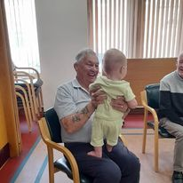 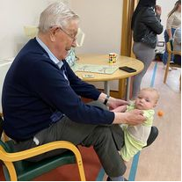

**STRICTLY NEWS**

The comedian Chris McCausland will be the first blind contestant to compete in Strictly Come Dancing when the TV show returns this year. The 47-year-old from Liverpool lost his sight in his early 20s as a result of retinitis pigmentosa.

Asked about how he feels about taking part he said “Apprehensive, massively apprehensive. I don’t know what I’m getting myself into. I’ve never watched it, obviously. It’s just some music”.

He added “If anybody out there is thinking “How the hell is he going to do that?’ then rest assured that I am thinking exactly the same thing. I don’t dance, I haven’t danced, I can’t dance. I can’t see the dancing I will have to do. What could possibly go wrong? OK don’t answer that.”

Good luck Chris and who knows we may see him get to the final and lift the famous Glitter Ball.

**Puzzle Time**

|  |  |  |  |  |  |  |  |  |  |  |  |  |
| --- | --- | --- | --- | --- | --- | --- | --- | --- | --- | --- | --- | --- |
|  | **1** | **2** |  | **3** |  | **4** |  | **5** |  | **6** |  | **7** |
| **8** |  |  |  | **9** |  |  |  |  |  |  |  |  |
| **10** |  |  |  |  |  |  |  | **11** |  |  |  |  |
|  |  |  |  | **12** |  |  |  |  |  |  |  |  |
| **13** | **14** |  |  |  |  | **15** |  |  | **16** |  |  |  |
|  |  |  |  |  |  |  |  |  |  |  |  |  |
| **17** |  |  | **18** |  |  |  | **19** | **20** |  |  | **21** |  |
|  |  |  |  |  |  | **22** |  |  |  |  |  |  |
| **23** |  | **24** |  | **25** |  |  |  | **26** |  | **27** |  | **28** |
|  |  |  |  |  |  | **29** |  |  |  |  |  |  |
| **30** |  |  |  |  |  |  |  | **31** |  |  |  |  |
|  |  |  |  |  |  | **32** |  |  |  |  |  |  |
| **33** |  |  |  |  |  |  |  | **34** |  |  |  |  |

**CLUES ACROSS**

**1 – THREESOME (4)   
 4** **– FLESHY FRUIT (7)**

**9 – SOFT HAIR (3)**

**10 – EMPLOYEES (5)**

**11 – JEWELLED HEADDRESS (5)**

**12 – BAKERY PRODUCT (3)**

**13 – MILITARY CHAPLAIN (5)**

**15 – ACADEMIC INSTITUTION (7)**

**17 – BASE BENEATH A STATUE (6)**

**19 – WILD AMERICAN CAT (6)**

**23 – BREAK (7)  
26 – RARING TO GO (5)**

**29 – FLOODED AREA OF LAND (3)**

**30 – WEASEL-LIKE ANIMAL (5)**

**31 – END PREMATURELY (5)**

**32 – DELAY BETWEEN EVENTS (3)**

**33 – FROM THE SIDES (7)  
34 – WATER JUG (4)**

**CLUES DOWN**

**2 – AUTHOR, ….. DAHL (5)**

**3 – UNUSUAL (7)**

**4 – JUMP ABOUT (6)**

**5 – ALLOY (5)**

**6 – PLAYING CARD (5)**

**7 – TIDEST (7)**

**8 – PLEASE REPLY (ints) (4)**

**16 – TELL PORKIES? (3)**

**17 – SUN UMBRELLA (7)**

**18 – NEGATIVE (3)**

**20 – MASSIVE SLAUGHTER (7)**

**21 – NOLONGER YOUNG (3)**

**22 – SUPPLY AGAIN (6)**

**24 – ALAIN ….., GRAND PRIX DRIVER (5)**

**25 – SAY, SPEAK (5)**

**27 – ON TOP OF (5)**

**28 – ABOMINABLE SNOWMAN (4)**

**WORD SEARCH**

|  |  |  |  |  |  |  |  |  |  |  |  |
| --- | --- | --- | --- | --- | --- | --- | --- | --- | --- | --- | --- |
| **B** | **O** | **M** | **E** | **I** | **R** | **S** | **E** | **R** | **Z** | **V** | **Z** |
| **N** | **R** | **R** | **I** | **D** | **L** | **T** | **B** | **K** | **B** | **C** | **M** |
| **D** | **S** | **A** | **A** | **M** | **E** | **A** | **R** | **R** | **I** | **R** | **A** |
| **B** | **G** | **A** | **I** | **B** | **Y** | **E** | **A** | **A** | **M** | **U** | **A** |
| **X** | **O** | **W** | **M** | **N** | **A** | **O** | **N** | **A** | **M** | **W** | **B** |
| **Y** | **D** | **O** | **O** | **W** | **B** | **B** | **G** | **B** | **T** | **P** | **M** |
| **M** | **I** | **U** | **E** | **M** | **Y** | **O** | **E** | **O** | **A** | **R** | **U** |
| **Y** | **Y** | **G** | **U** | **S** | **O** | **O** | **R** | **A** | **P** | **D** | **P** |
| **D** | **Y** | **D** | **G** | **B** | **N** | **A** | **B** | **A** | **T** | **A** | **E** |
| **A** | **O** | **P** | **L** | **Y** | **O** | **E** | **V** | **I** | **L** | **O** | **D** |
| **L** | **R** | **O** | **O** | **X** | **F** | **M** | **E** | **P** | **J** | **I** | **S** |
| **H** | **N** | **E** | **R** | **O** | **A** | **S** | **Y** | **Z** | **X** | **B** | **M** |
| **V** | **A** | **D** | **U** | **N** | **N** | **A** | **P** | **I** | **Y** | **I** | **E** |
| **L** | **I** | **B** | **M** | **A** | **B** | **S** | **E** | **O** | **N** | **E** | **E** |

**WORD SEARCH – SUSPENSION BRIDGES**

**BABAR PUMBA**

**BAMBI RANGER**

**BRAIN SMEE**

**DIXIE SNEEZY**

**DUMBO SNOOPY**

**LADY TRAMP**

**MR MAGOO WOODY**

**OLIVE OYL**

**So-Duko**

|  |  |  |  |  |  |  |  |  |
| --- | --- | --- | --- | --- | --- | --- | --- | --- |
|  | **9** |  | **7** |  |  |  |  |  |
| **3** |  |  | **5** | **6** |  |  | **1** | **9** |
|  | **8** | **5** |  |  | **9** | **6** |  |  |
| **1** |  |  |  |  | **7** |  | **4** | **5** |
|  | **3** |  |  |  |  |  | **8** |  |
| **8** | **4** |  | **2** |  |  |  |  | **6** |
|  |  | **8** | **3** |  |  | **4** | **2** |  |
| **9** | **1** |  |  | **7** | **2** |  |  | **3** |
|  |  |  |  |  | **1** |  | **9** |  |

CROSSWORD SOLUTION

**Puzzle Time**

|  |  |  |  |  |  |  |  |  |  |  |  |  |
| --- | --- | --- | --- | --- | --- | --- | --- | --- | --- | --- | --- | --- |
|  | **T** | **R** | **I** | **O** |  | **P** | **U** | **M** | **P** | **K** | **I** | **N** |
| **R** |  | **O** |  | **F** | **U** | **R** |  | **E** |  | **N** |  | **E** |
| **S** | **T** | **A** | **F** | **F** |  | **A** |  | **T** | **I** | **A** | **R** | **A** |
| **V** |  | **L** |  | **B** | **U** | **N** |  | **A** |  | **V** |  | **T** |
| **P** | **A** | **D** | **R** | **E** |  | **C** | **O** | **L** | **L** | **E** | **G** | **E** |
|  | **I** |  |  | **A** |  | **E** |  |  | **I** |  |  | **S** |
| **P** | **L** | **I** | **N** | **T** | **H** |  | **O** | **C** | **E** | **L** | **O** | **T** |
| **A** |  |  | **O** |  |  | **R** |  | **A** |  |  | **L** |  |
| **R** | **U** | **P** | **T** | **U** | **R** | **E** |  | **R** | **E** | **A** | **D** | **Y** |
| **A** |  | **R** |  | **T** |  | **F** | **E** | **N** |  | **B** |  | **E** |
| **S** | **T** | **O** | **A** | **T** |  | **I** |  | **A** | **B** | **O** | **R** | **T** |
| **O** |  | **S** |  | **E** |  | **L** | **A** | **G** |  | **V** |  | **I** |
| **L** | **A** | **T** | **E** | **R** | **A** | **L** |  | **E** | **W** | **E** | **R** |  |

**So-Duko**

|  |  |  |  |  |  |  |  |  |
| --- | --- | --- | --- | --- | --- | --- | --- | --- |
| **6** | **9** | **1** | **7** | **3** | **8** | **2** | **5** | **4** |
| **3** | **7** | **2** | **5** | **6** | **4** | **8** | **1** | **9** |
| **4** | **8** | **5** | **1** | **2** | **9** | **6** | **3** | **7** |
| **1** | **2** | **6** | **9** | **8** | **7** | **3** | **4** | **5** |
| **5** | **3** | **7** | **1** | **6** | **9** | **9** | **8** | **2** |
| **8** | **4** | **9** | **2** | **5** | **3** | **1** | **7** | **6** |
| **7** | **6** | **8** | **3** | **9** | **5** | **4** | **2** | **1** |
| **9** | **1** | **4** | **8** | **7** | **2** | **5** | **6** | **3** |
| **2** | **5** | **3** | **6** | **4** | **1** | **7** | **9** | **8** |

